**Take-Home Exam CUDA_HTT**

*Parallel Programming & Architectures*

# Consideration

* Your code is automatically graded using a script, and therefore, if your file/folder names are wrong you will receive a grade of **zero**. Please read and follow the instructions carefully. Common mistakes include

o Different file or folder names

o Different formatting of input or output

o Not paying attention to case sensitiveness of C++ and Linux

* Go to the folder ~/the/cuda_htt/ in your home directory on the server and put your codes in this directory and remove any compiled binaries and test cases.
* Make sure your code compiles and runs without any error **on the server**. Your grade will be **zero** if any compile or runtime error occurs on the server. **Any!**
* The provided test cases, examples and sample codes (if any) are only to better describe the question. They are **not** meant for debugging or grading. It is your responsibility to think of and generate larger and more complex test cases (if necessary) in order to make sure your software works correctly for all possible scenarios.
* Start early and don’t leave everything to the last minute. Software debugging needs focus and normally takes time.
* Just leave your final programs on the server. **Don’t** email anything!
* Your grade is divided into several parts. In all cases, if you miss **correctness** (i.e. your code doesn’t satisfy desired functionality), you miss other parts (e.g. speed, coding style, etc.) too. This rule is applied separately for each section of a take-home exam. So for example, in cuda_mm, your code might not be correct for M >= x but still you will get your grade for lower M values.
* Talking to your friends and classmates about this take-home exam and sharing ideas are *OK*. Searching the Internet, books and other sources for any code is also *OK*. However, copying another code is **not OK** and will be automatically detected using a similarity check software. In such a case, grades of the copied parts are **multiplied by -0.5**. Your work must be 100% done only by yourself, and you **should** **not** share parts of your code with others or use parts of other’s codes. Online resources and solutions from previous years are part of the database which is used by the similarity check software.

# *bmm.cu* – Heat Transformation with Texture Memory

**Grade:** *20%* correctness, *80%* speed

Consider a two-dimensional room that is divided into cells, with each cell having a temperature randomly ranging between *20* to *30* degrees Celsius. As each cell has a different temperature from its neighbors, heat transformation occurs between these cells and their neighbors in order to establish thermal balance.

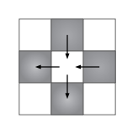

Heat dissipating from warm cells into cold cells

And we can model this heat transformation with an equation like this:

In this equation, the new temperature for each cell depends on the various temperatures of the neighboring cells, incorporating the constant 'K'.

So, in a two-dimensional scenario, we consider neighbors located at the top, bottom, right, and left, and therefore, we utilize this equation.

matrices of size *N × N*, where *N = 2M*. We would like to calculate *C = A × B*. Parameter *M* should be a command line argument to the *main()* function. Your program must work correctly for any value *10 <= M <= 13*. Note that larger arrays, for example M=14, may not fit into the GPU global memory. Your program must fill *A* and *B* with random float values between *-8.0f* and *+8.0f* using *srand()* and *rand()* functions.

You must use the block matrix multiply algorithm explained in class. Each block computes one square sub-matrix *Csub* of size *TILEX×TILEY*. Each thread computes one element of *Csub*. See the following figure (Chapter 5 in David Kirk’s book). Parameters *TILEX and TILEY* should be defined on top of bmm.cu using two *#define* directives. Your program must work correctly for TILEX and/or TILEY equal to 4, 8, 16 and 32, but you should tune both of them in your code in order to gain the best possible speed. Note: Please do not confuse TILEX and TILEY with TX and TY which correspond to thread index in a CUDA block.

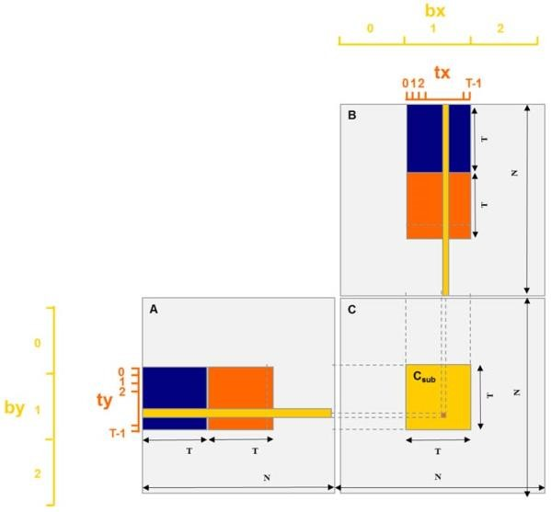 tx = threadIdx.x ty = threadIdx.y bx = blockIdx.x by = blockIdx.y

Check correctness of your calculations by comparing the final values from GPU with results given by a serial matrix multiply function executed in CPU. Note that in order to reduce the time of CPU calculations, the CPU function only calculates two rows of matrix C when M  10. So the CPU time is not valid for these values of M. Refer to the provided bmm_main.cu file for the details.

Use the provided gpuerrors.h, *gputimer.h, bmm_main.cu, bmm.h* and *bmm.cu* files to start your work. Only modify *bmm.cu*. Check the speed of your calculations as shown in the provided *bmm_main.cu* file.

**Compile:** *nvcc -O2 bmm_main.cu bmm.cu -o bmm*

# Execute: *./bmm M*

Note that *N* is equal to *2M*.